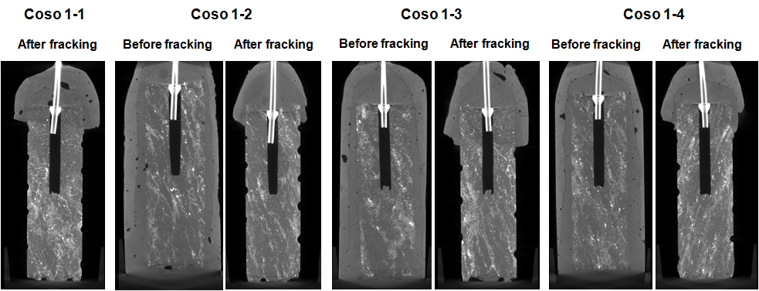

Fig. S9. XMT images of rock cores from Coso geothermal site, CA before and after hydraulic fracturing experiment using 1 wt.% PAA and CO2 (Coso 1-1 and 1-2), 1 wt.% SDS and CO2 (Coso 1-3), and distilled water and CO2 (Coso 1-4). Confinement pressure= 204 atm (3000 psi), confinement temperature= 210 ºC. Successful rock fracturing with PAA performed by duplicate (samples Coso 1-1 and Coso 1-2) at differential pressures of only 4 and 7 atm (60 and 100 psi). No XMT image is available for Coso 1-1 before hydraulic fracturing experiment.



Fig. S10. Pictures of CO2 leakage experiment at ~7 atm CO2 pressure. CO2 bubbling from the rock surface was observed from the rock cores Coso 1-1 and Coso 1-2 (photos A and B) after hydraulic fracturing experiment with 1 wt.% PAA and CO2. No evidence of fractures was observed for DIW and CO2 or 1 wt% aqueous SDS and CO2 (photos C and D).



Fig. S11. Pictures of the injection of KI solution (0.3 g/mL) into the rock cores at ~7 atm N2 after the hydraulic fracturing experiment with 1 wt.% PAA and CO2. The seepage of KI solution occurred through the fractured rock surface.

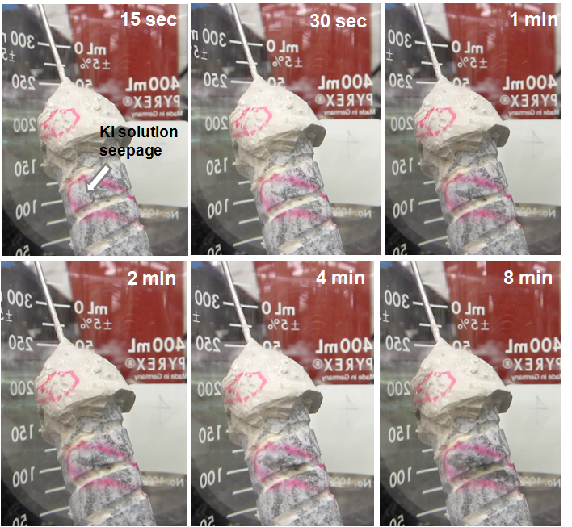

Fig. S12. Time-series of the seepage of the KI solution injected into the rock core (Coso 1-2) at ~7 atm N2 pressure. The seepage of KI solution occurred on the upper left side of the rock surface within the red mark in 15 seconds, and then the seepage of KI solution occurred along a line within the red mark, which is presumed to be micro-fractures. Based on the observed seepage velocity of ~0.4 mm/s (Fig. S12), the intrinsic permeability of the fractures formed on Coso 1-2 was calculated using Darcy’s law to be approximately 5 × 10-15 m2 (5 mD), which is comparable to the typical permeability of sandstone reservoir rocks



Fig. S13. XMT images of a horizontal slice of the fractured rock core (Coso 1-2) before and after the injection of KI solution (0.3 g/mL) at 7 atm N2 pressure. After the injection of KI solution, the cement sealing remaining on the outside surface of the rock core became brighter because of the seepage of KI solution.

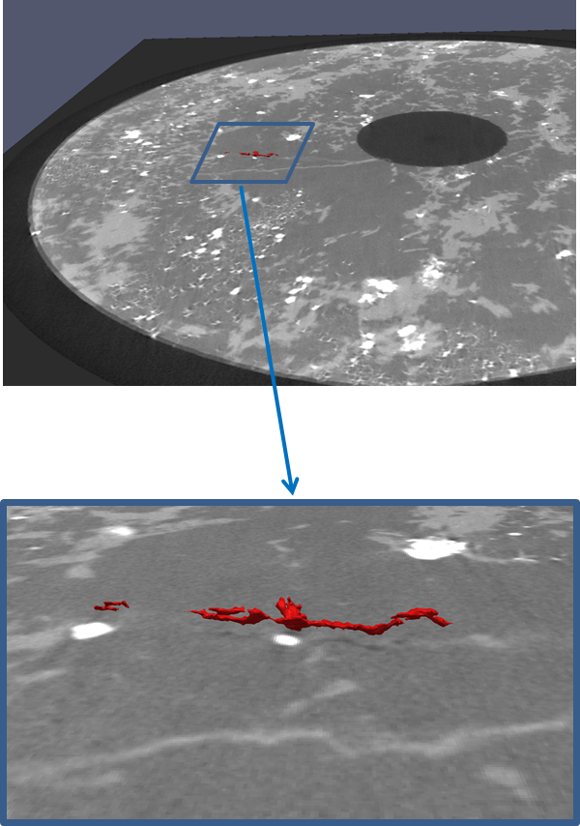

Fig. S14. XMT image of a volume spanning 20 horizontal XMT slices on the fractured rock core (Coso 1-2) showing the presence of a local fracture created at 4 atm differential pressure. It is important to note, that although the fracture seems not to connect the internal void volume of the rock with its external surface, microfractures smaller than the resolution limit of the instrument are present and allow fluid flow through the rock as evidenced by CO2 and KI flow experiments.